**Install Node.js on Mac**

**Installation Steps**

1. **Download the Mac installer from the**[**Nodes.js® web site**](http://nodejs.org/)**.**
2. 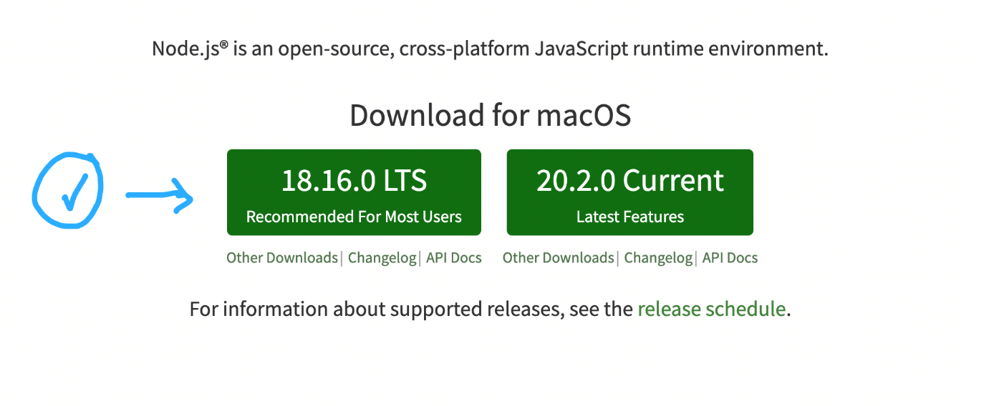**Choose the Long Term Support version**that’s shown on the left.
3. **Run the installer** (double-click on the .pkg file you downloaded in the previous step.)

NOTE: If you are running macOS Catalina 10.15, you might get a warning pop up that looks like this:

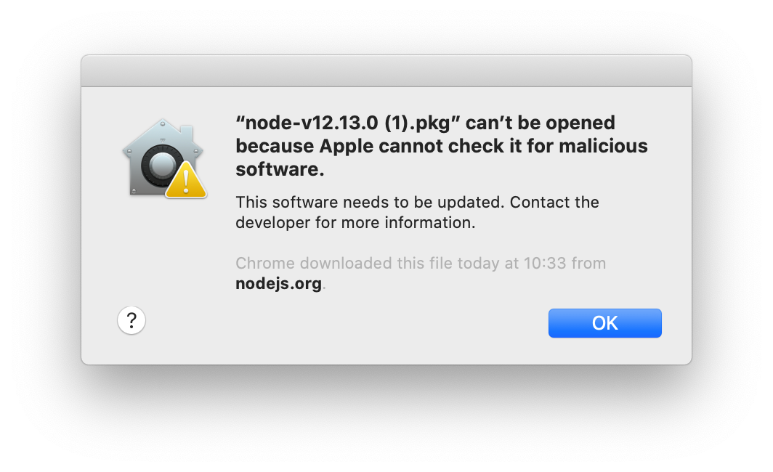

To solve this issue, just right click (hold down the control key on the keyboard and click) on the .pkg file and select "Open With" and then select "Installer (default)".

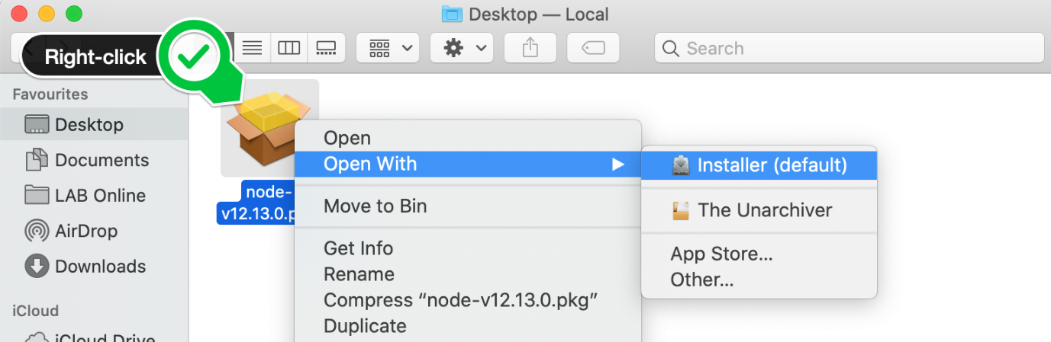

1. **Follow the prompts in the installer** (Accept the license agreement, click the NEXT button a bunch of times and accept the default installation settings).
2. Confirm that node has been installed successfully by opening a Hyper terminal and entering the command

node --version

You should see the version of node you have just installed.